Second Practical Use Case
The second use case illustrates a manufacturing workflow focused on the production order management of a real-world company whose name also cannot be disclosed.
The process begins when the system indicates that components must be manufactured. The production operator first checks the work center's worklist and then determines if priority orders exist. If priority orders are confirmed, they are prioritized before the operator selects the next production order. If no priority orders exist, the process directly proceeds to selecting the next order. After the selection of orders, the system checks if tools are not available at workcenter. In case that tools are missing, the operator request required tools by the tool preparator. The tool preparator, who receives the request, prepares requested tools, and sends them back and allows the production operator to continue.
When the tools are available, the operator proceeds directly to check if components required are present. If components are required, the operator verifies the supply area for delivered components. If missing parts exist and components are required to start, the operator must wait for delivery confirmation. After all necessary components are confirmed (or if components were not required), the process ends.
The use case also contains FRs relevant to IEC62443-3 that were identified in collaboration with process experts. The FRs and controls are outlined as follows:
- FR2: When opening the worklist for the work center, rolebased_access must be true, that only persons with the necessary privileges can access to the production schedules.
- FR3: To safeguard the integrity of planning data, dataintegrity_check must be true to prevent the selection of manipulated or corrupted orders.
- FR3: The messages between the production operator and the tool preparator must have the protocol_type kerberos.
- FR4: The messages must also be sent in encrypted form; therefore, encryption must be true.
- FR6: To ensure accountability and forensic capability, the resource must maintain logging, defined by audit_log: true. Additionally, the log retention time for the delivery check is set to log_retentiontime: 365.
- FR7: The resource is configured with component_inventory:true, ensuring the availability and tracking of required production assets.
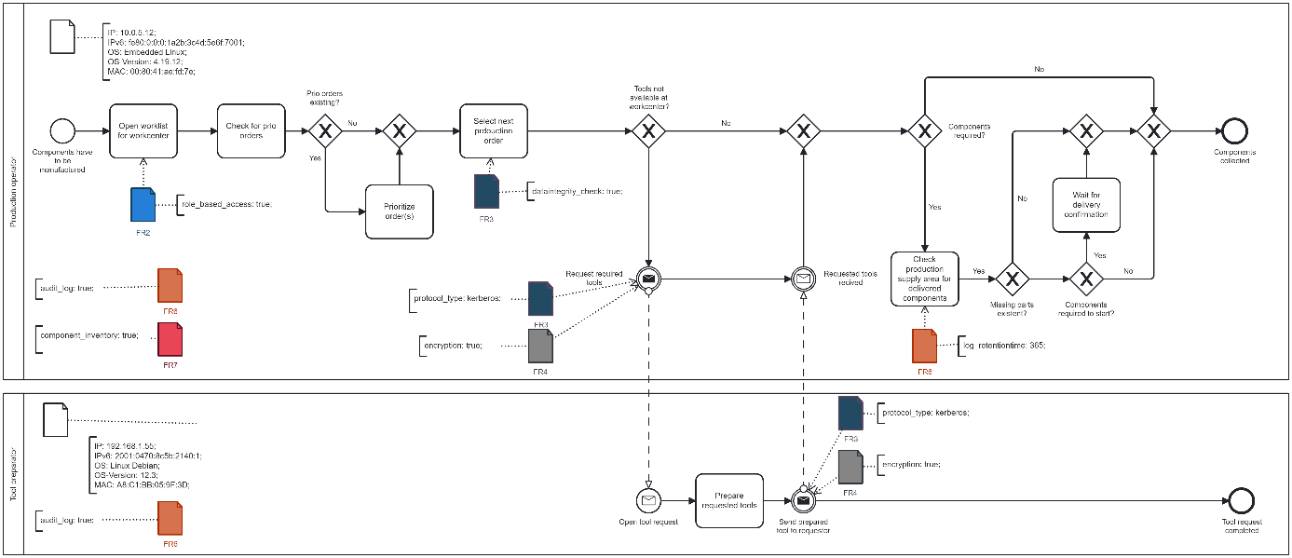
Figure 5. Process for tool preparation that must fulfill IEC62443-3 controls.

